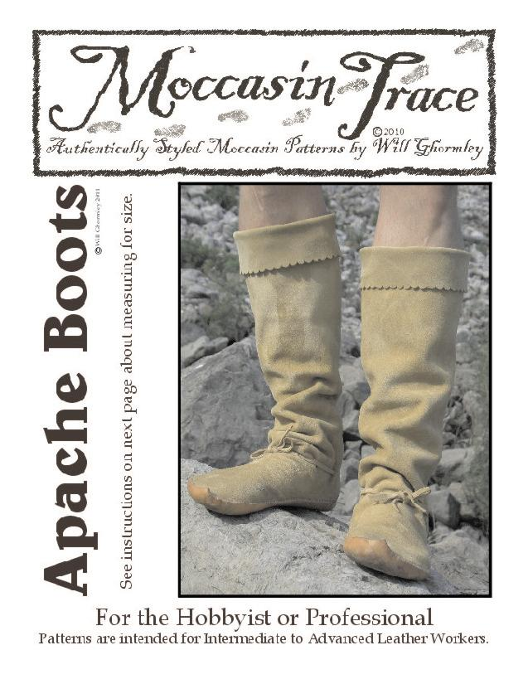
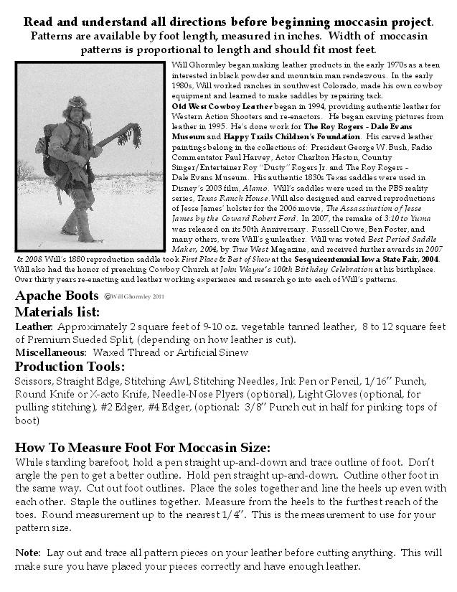
The various Apache groups filtered down from western Canada’s Athabaskan population. The migration may have started as early as 1000 A.D. with the different groups moving down the mountains and spreading out across the plains. Their arrival in the southwest predated Spanish discovery, when the Apachean peoples had already displaced or replaced earlier societies. The Apachean language group people had splintered into different identifiable divisions, some of which were: Navajo, Western Apache, Chiricahua, Mescalero, Jicarilla, Lipan, and Plains Apache (Kiowa).

The Apache people refer to themselves as “Inde”, the Mescalero word for “person”. The actual name “Apache” may come from the Zuni word for “Navajos”, or from the Yavapai word for “enemy”. There is also a chance it may have come from the Spanish word for “raccoon”. There isn’t a definitive universal agreement on the source.

The distinctive Apache Boot was worn by both men and women, where in other First Nations, wearing boots was more common among women. The rugged terrain, bristling with thorny plants and paved with jagged rocks and scalding sand, may very well have been the deciding factor in adopting the common use of boots as footgear. Whether the boots were a holdover from the chills of their Athabaskan Canadian origins, an influence of Spanish invaders, adopted from displace tribes, or inspired by climate and terrain, the Apache Boot is perhaps the most distinctive and universally identifiable footgear among First Nations peoples.

Before beginning the moccasin project, look ahead, read and understand all instructions before you start.
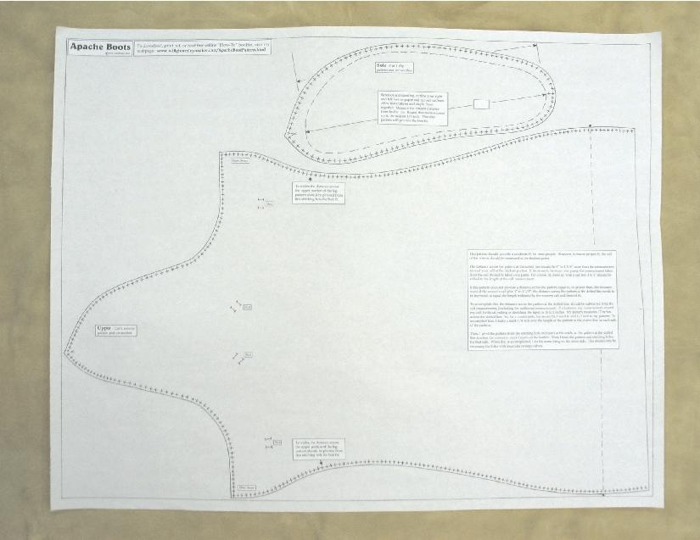

For the construction of this hard-sole boot, the uppers should be made of moccasin type leather. For the sake of this pattern, Premium Sueded Split, which is widely available, will be used. The formed soles will be constructed from 9-10 oz. vegetable tanned leather, commonly used in the construction of holsters and belts and lighter portions of sturdy saddles. Other materials can be substituted, but for the pattern to work well, they must be of similar thickness and character.

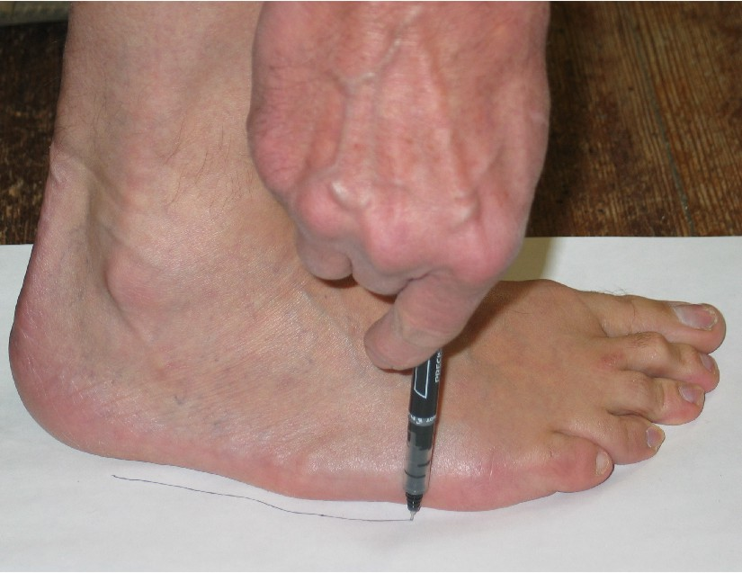
First, standing on a paper, trace your foot, holding the pen straight up and down. Don't tip the pen or edge it in to get a better tracing. Just run it around your foot with it straight up and down as shown in the photo. Then, trace your other foot the same way. If you plan on wearing socks with your mocs, trace your foot wearing socks.

Cut out each foot outline. Then, flip one over, line up the heels evenly, and staple together. Measure the outline from the extreme end of the heel to the furthest tip of the longest toe. Round this measurement UP to the next ¼”. For instance, if your combined foot outlines measure 10 & 1/8”, round that up to 10 & ¼”. If you are measuring children’s feet, account for some growth room of at least an extra half-inch.

The sole and upper patterns should be cut out, and the stitching marks punched out with a 1/16” Punch.

To determine if the upper portion of the boot pattern will fit around your calf, first, measure your calf. If you intend to wear the boots over pants, measure your calf over pants. Don’t pull the tape tight.

Near the top of the upper pattern, there is a dotted line. The length of that line will vary depending on the size of your pattern. Measure the distance across the dotted line from one side to the other. That distance must be at least one inch longer than the distance around your calf. The larger the boot, the bigger the distance should be. For instance: My foot tracing measures 11 ¼”. My dotted line measures 17”. My calf, over my jeans, measures 16 ½”. So, my pattern at the dotted line needs to be at least a half inch longer. That means I need to extend the length of that line by ¼” on each side. We’ll cover how to extend that measurement in a few steps. But first, we must begin to trace the uppers.

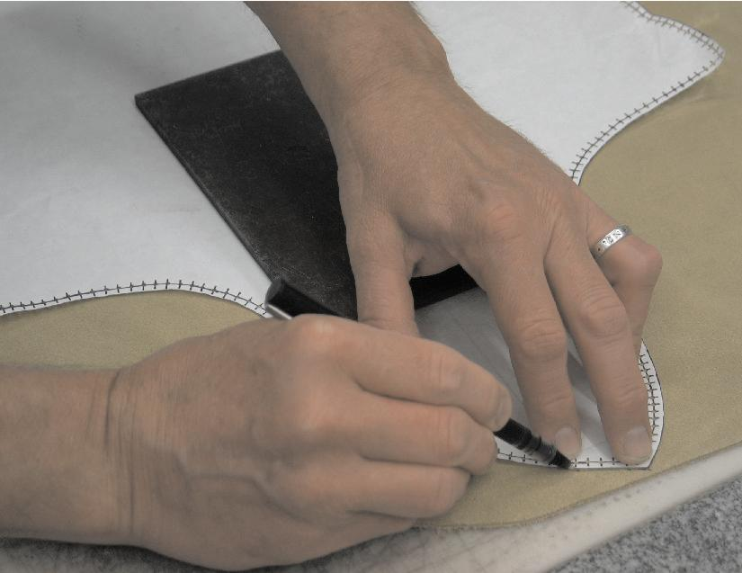
The uppers should be traced on the side of the leather that will be on the inside of the boot. This way your pen or pencil marks won’t be seen. If you don’t need to adjust your pattern to fit over your calf, you can trace the whole uppers just as they are.

However, if you do need to adjust the pattern larger, trace the toe section of the uppers up to the stitching hole that is marked on the pattern just above the heel.

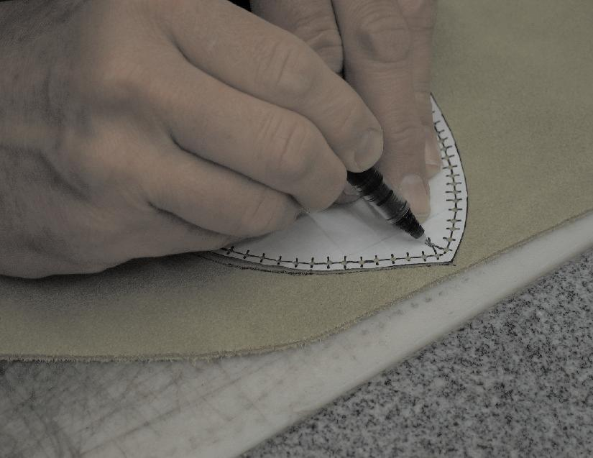
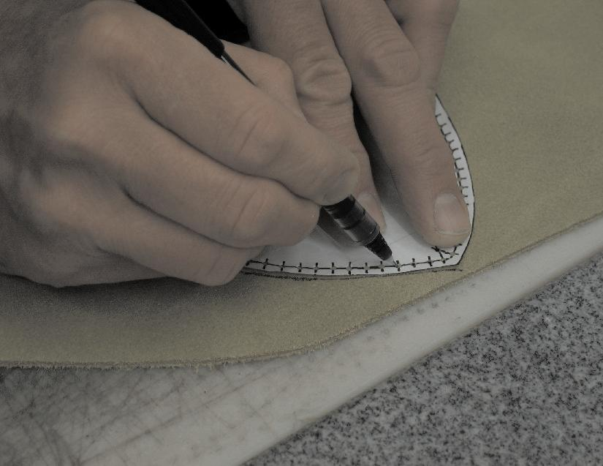
The two holes to be used when beginning stitching the soles to the uppers are marked with an “x” as shown in this photo. A mark should be made on the upper to insure stitching begins with these two holes.

Each of the stitching holes should be marked through the 1/16” holes that have been punched, as shown at the right.
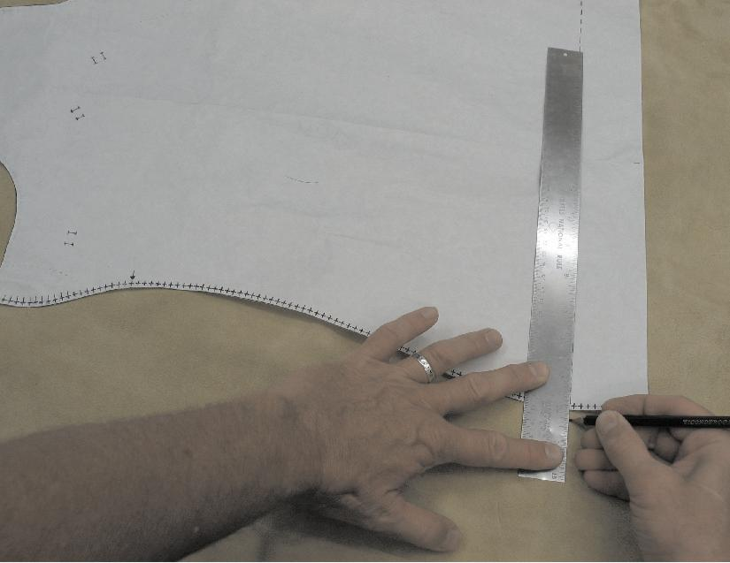
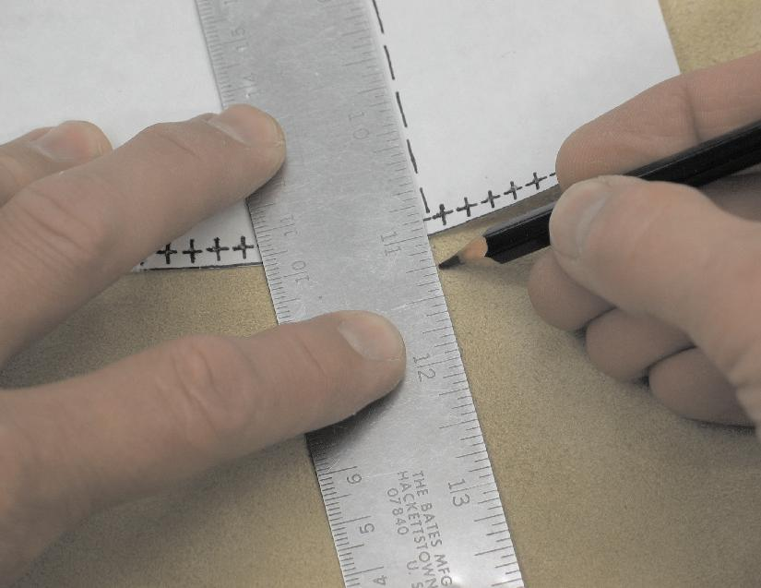
Without shifting the pattern, add half of the needed extension to both sides of the pattern. At the left, ¼” is being added to each side for a total lengthening of ½”.

Close up, adding the extra length to each side looks like the photo to the right.

With the mark made on each side of the pattern, adding the total extra length needed, it is time to shift the pattern to add the extra width to the upper leg portion of the pattern.

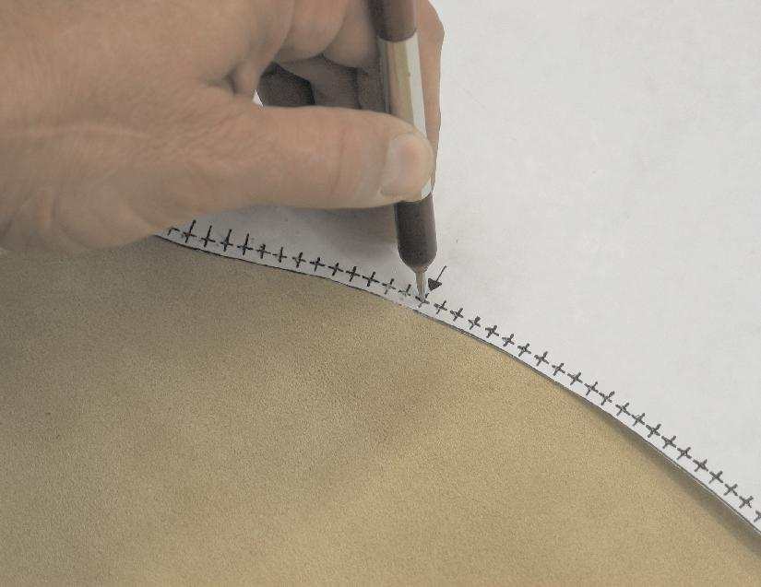
To shift the pattern, put a stylus, pencil, or pen in the stitching hole above the heel marked with the arrow.

Without tearing out the stitching hole, rotate the pattern at the stitching hole, shifting the edge of the pattern at the dotted line out to the extension mark on the leather. Trace that side of the pattern and the stitching holes, marking the top corner of the pattern.

Then, re-align the pattern to its original position. Placing the stylus, pen, or pencil in the opposite marked stitching hole, rotate the pattern on the other side so the edge of the pattern touches the mark on the leather at the dotted line. Trace the other side of the pattern with the stitching holes, marking the top corner of the pattern. With the pattern removed, draw a straight line across the top of the pattern connecting the corner marks on each side.

The pattern is then flipped over, and the exact same steps taken to make the other upper. NOTE: Boot uppers should be cut as close to the spine of the hide as possible, and oriented the same direction. If the two uppers run in different directions, one will sag more than the other. Preferably, the uppers should run top to bottom, aligned with the neck and tail of the hide. Cut out the uppers.

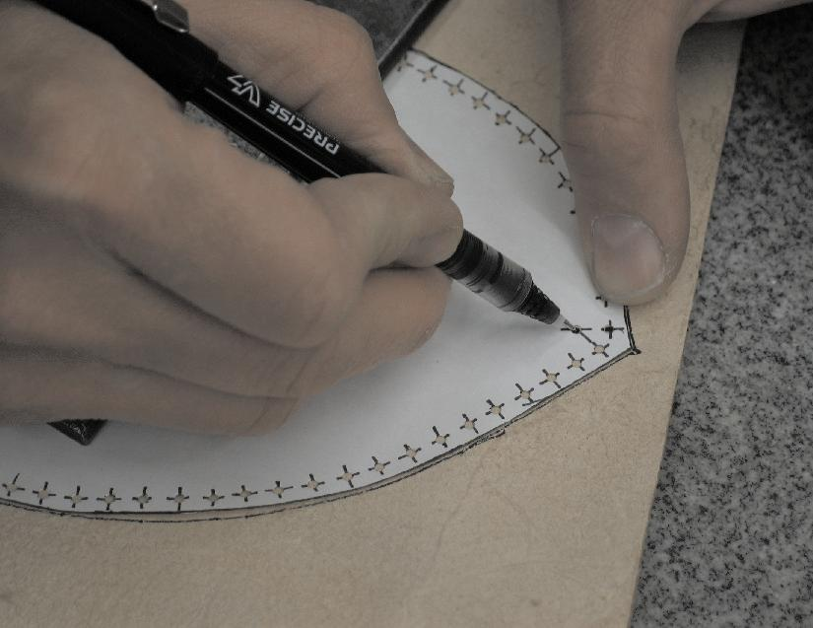
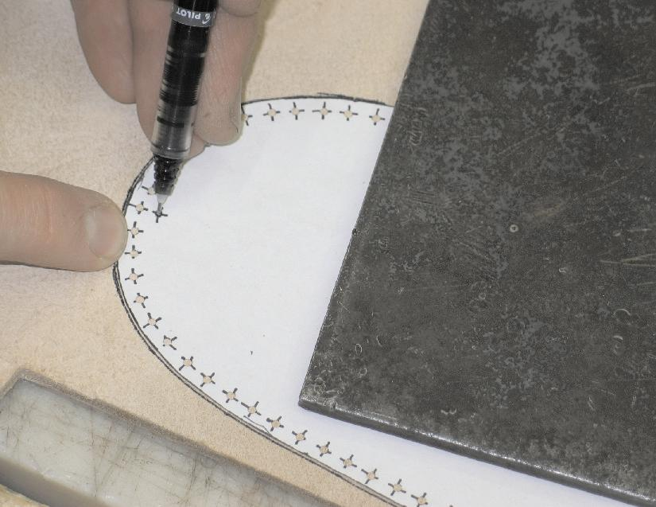
The next step is to trace the soles onto the 9-10 oz. leather. The soles should be marked on the flesh side of the leather that will be inside, so the marks don’t show on the finished boot. As shown in the photo to the right, mark the “x” between the two holes that will be the beginning stitch holes.

There is a double mark where the heel seem will line up with the sole. This should be marked as shown to the left. These starting and ending marks should not be pokes through the leather. They are just for marking, not stitching. When sole is completely marked, flip the pattern over and trace the other sole.

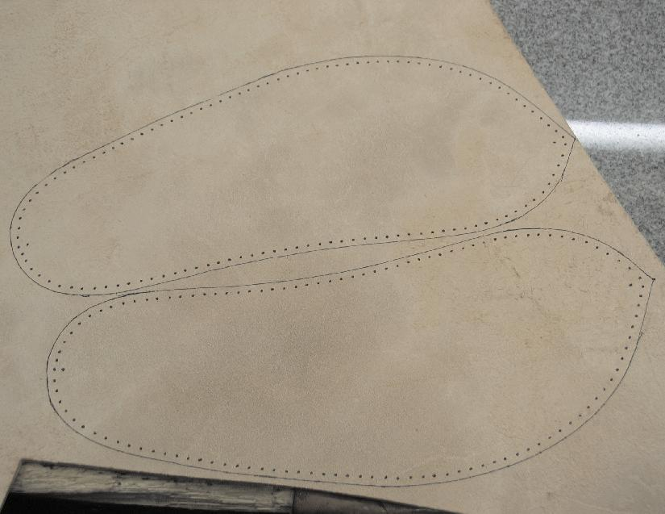
Soles should be cut as close to the spine of the hide as possible. They should be oriented in the same direction so they wear in the same manner.

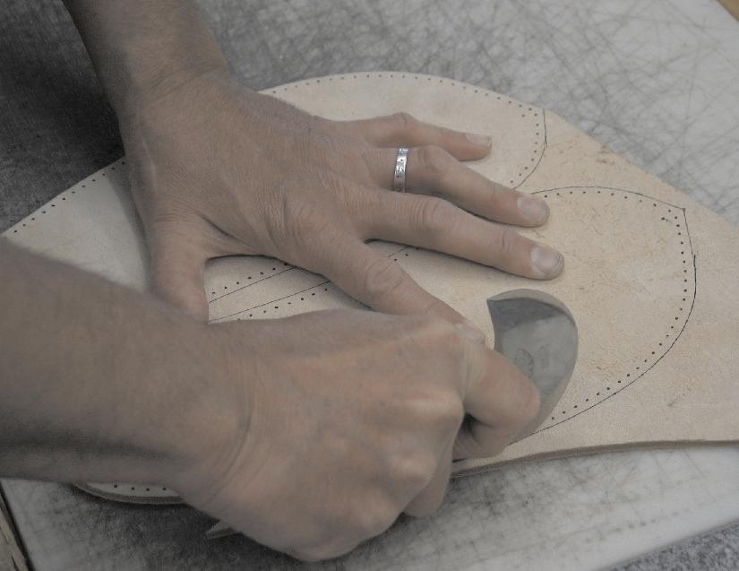
To the right, soles are being cut out with round, or head knife.
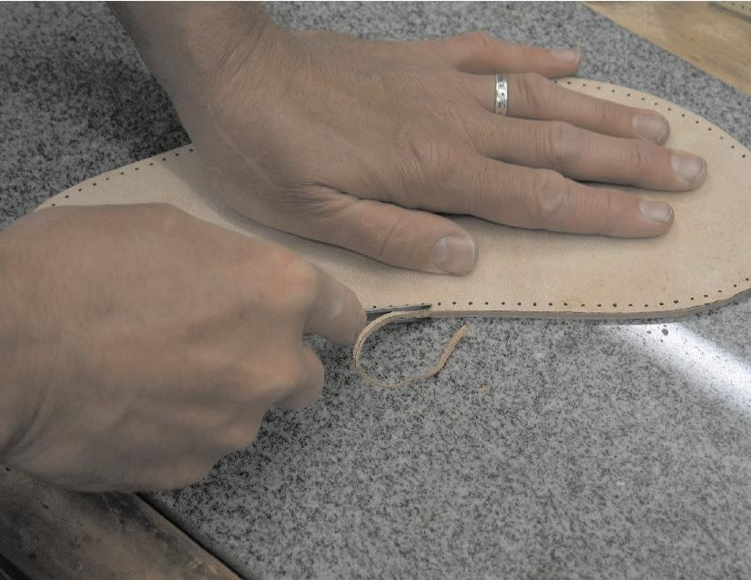
After soles are cut, the inside edges need to be trimmed off with a #4 Edge Beveler. This will eliminate a sharp edge inside the boot to wear against your foot.
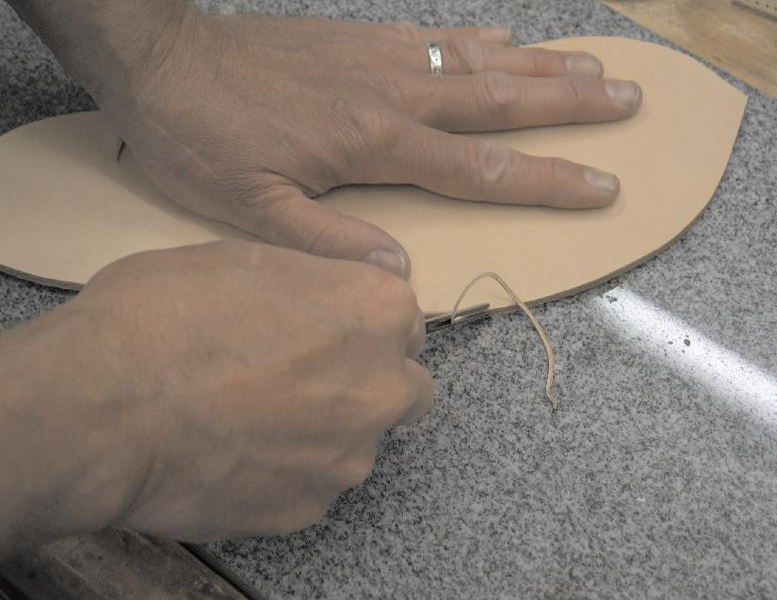
Flip the sole over and trim off the outside edge with a #2 Edge Beveler. This will give your boot a more finished look.
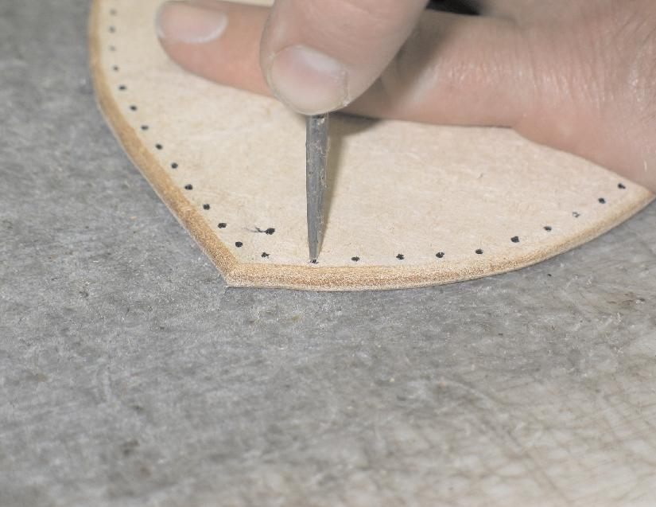
From the flesh, inside of the sole, begin to make the stitching holes. Start each hole with the awl at a 90 degree angle. It is important to stay away from the edge of the leather to keep from tearing through as the whole is being made. If you do rip through the leather, make a second stitching hole further back from the edge.

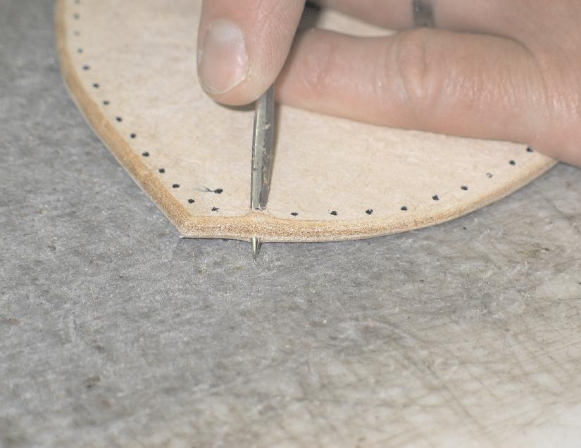
After tip of awl has pierced the surface of the leather, angle the awl so the tip of the blade exits the side of the leather as shown in the photo to the left.
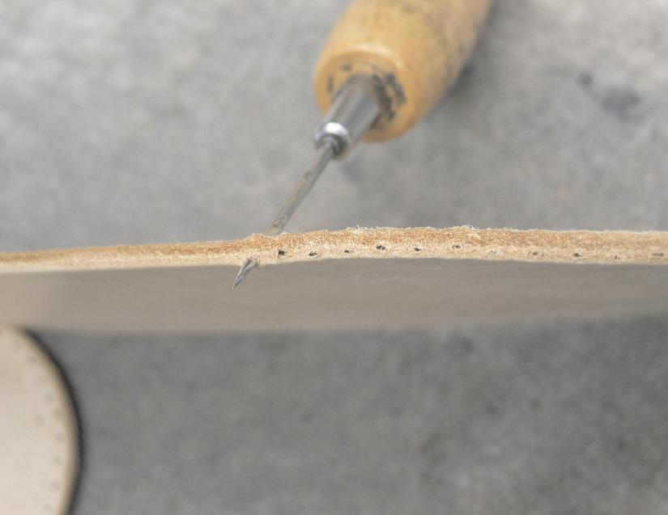

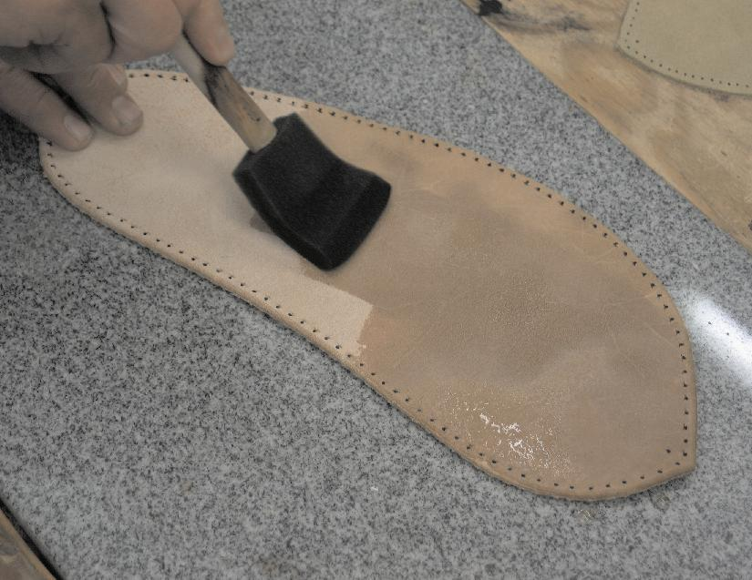
From the edge, the line of exit holes should look like the photo on the right.

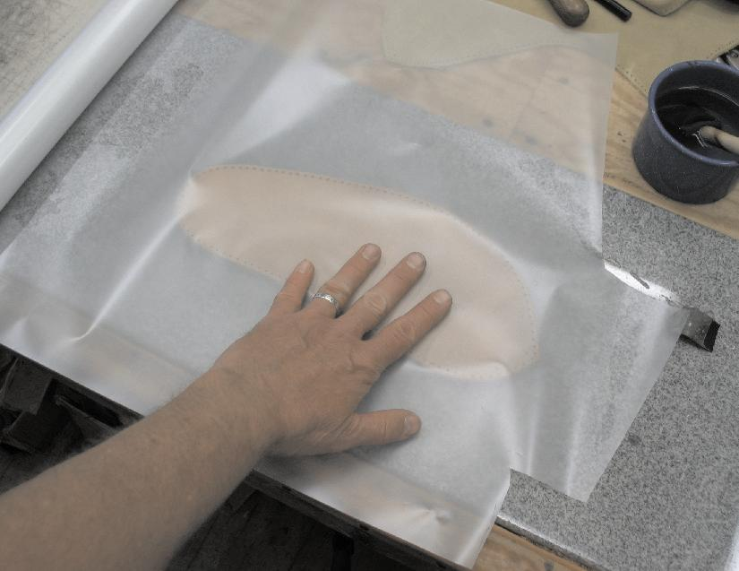
After all the stitching holes are made, the soles need to be moistened. I use a foam brush as shown to the left.

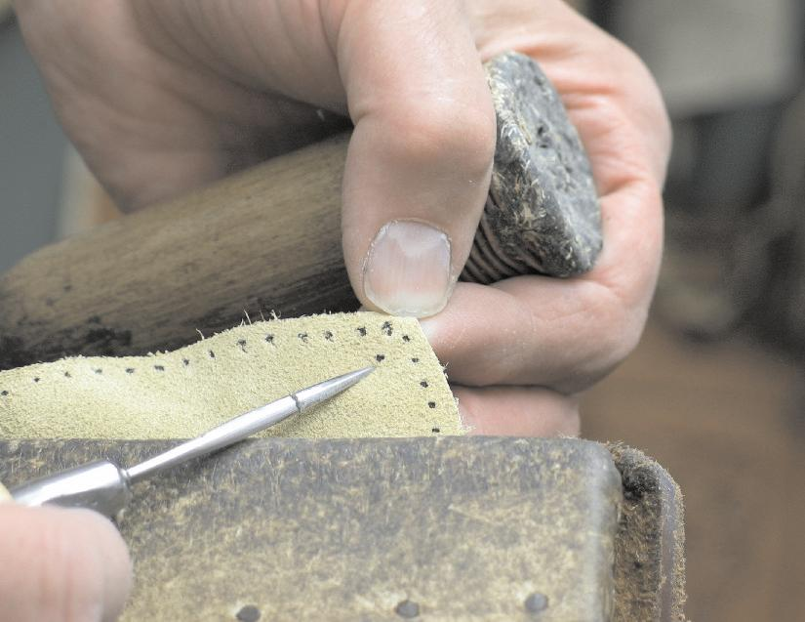
After moistening both sides, I stack the soles and cover them with plastic to allow the moisture to evenly distribute itself throughout the fibers of the leather. This is called casing. It can take from several hours to over night. Set the soles aside to case and work on other parts of the boots.

The stitching holes in the uppers need to be made. In the photo to the left I point out the mark that indicates where stitching will begin. This mark does not get punched through. It simply indicates where the stitching will start at the point of the toe.

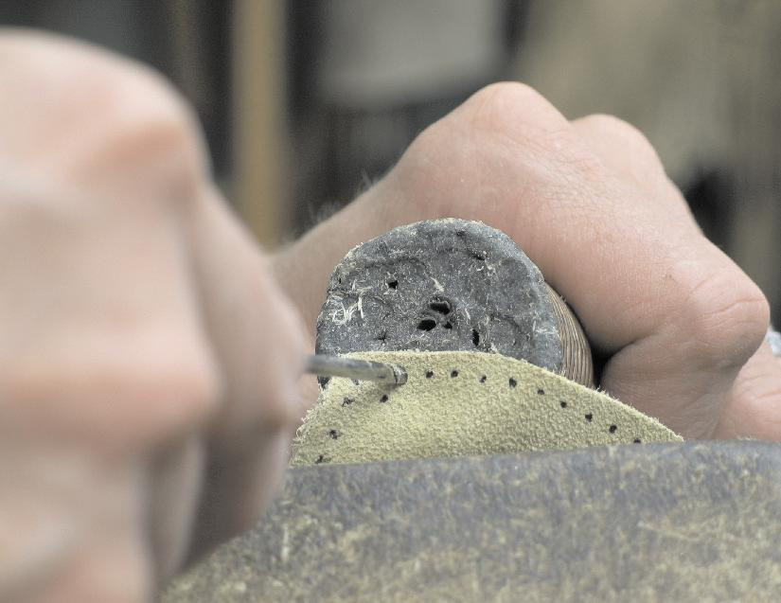
Here I pierce through the stitching holes with an awl, backed by a dowel with wax on the end.

When all the stitching holes are made in the uppers, the decorative “pinking” of the tops of the boots can be done if desired. The tops of the boots can be left straight, or pinked. Different methods of pinking were used. In the Old West, pinking was usually done with a punch.
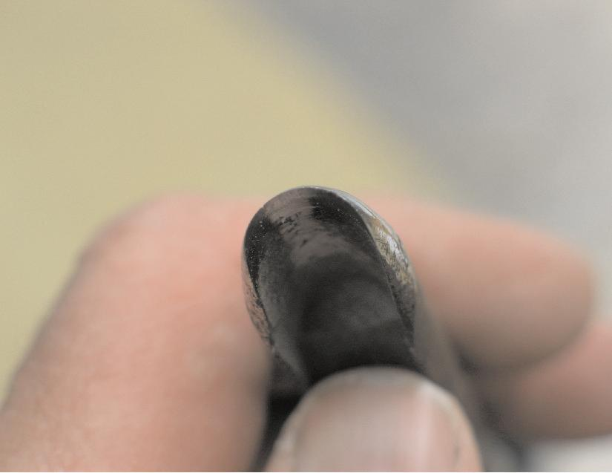
Pinking punches can still be purchased, but I made mine out of a 3/8” punch. I hacksawed and ground off one half of the punch to make a curved cutting tool as shown to the right.
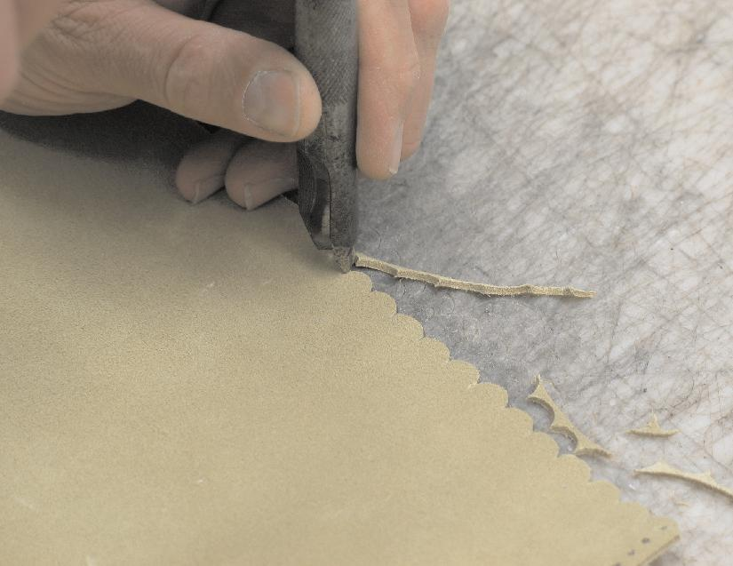
The punch is then used side by side along the top edge to create the decorative pinking. A little overlapping of the punch helps to achieve a clean cutaway from the upper.

A freehand zig-zag pinking can also be done with a knife by cutting connecting “v”s along the top edge.
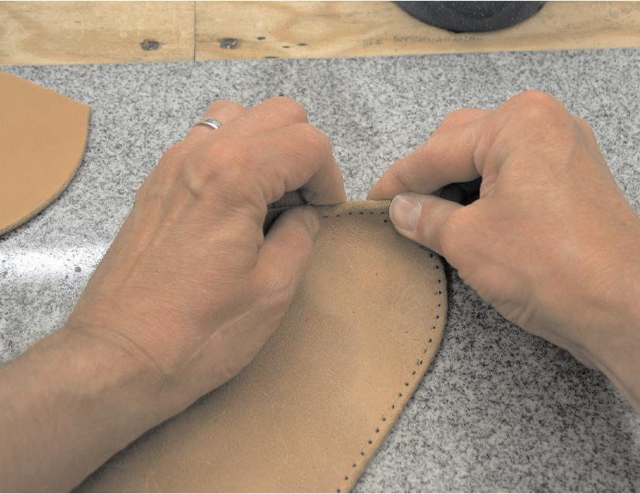
After a couple of hours, if the moisture has evened out through the soles, it will be time to form the edges of the soles. If the leather is too wet, the leather will not retain its new shape. If the leather is too dry, it will not easily be formed to its new shape. The leather should be malleable and the consistency of clay.

If it is too wet, let it stand in the open air and check it periodically. If it is too dry, moisten it some more and cover it with plastic again. Check it after an hour to see if it is malleable enough. If not, moisten and cover again. If it is too wet, uncover and allow to stand until it is the right consistency. It is important to have the moisture content of the leather as close to perfect as possible. It will make molding your soles much easier.
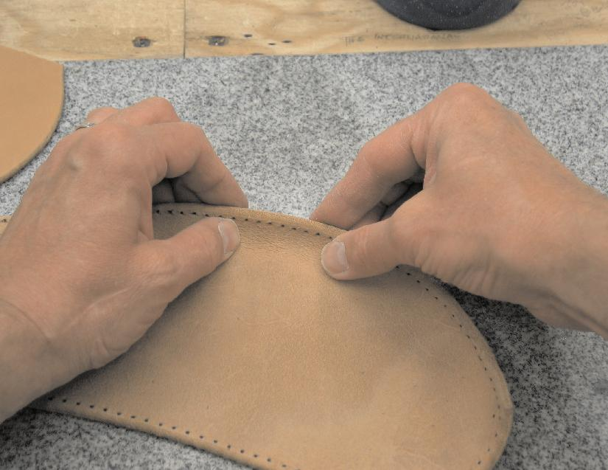
Firmly curl up the sole all around the edges. Areas like the heel and toe will need extra attention.

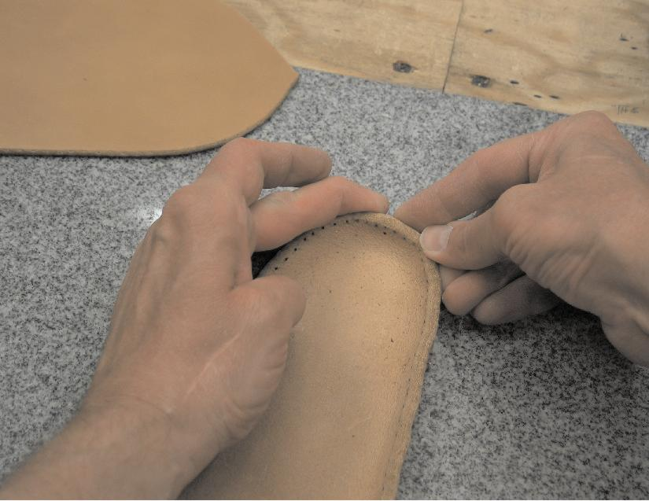
Around the heel the leather actually needs to be compressed together to eliminate wrinkles.
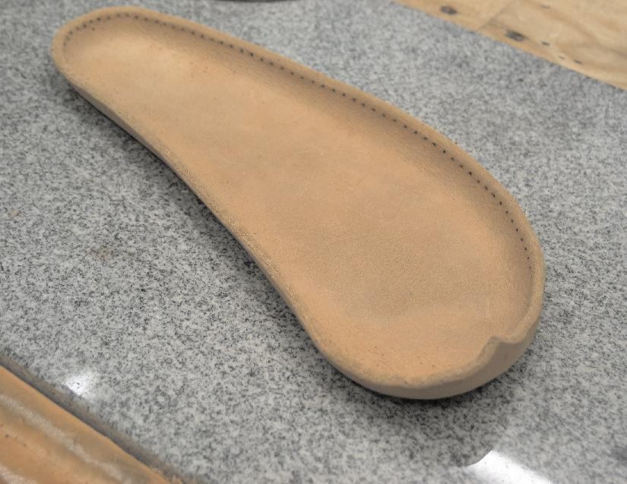
The sole needs to be compacted while curling up the toe as well. After the whole edge of the sole has been turned up, go back and rework the heel and toe to make sure you have the best, most consistent curl, without any wrinkles. Check to make sure the sole is turned up evenly around the whole sole, except for the toe. The toe should curl up more than the rest of the sole to create that distinctive Apache Boot toe.

When the sole has been formed, set it aside to dry while working on the next steps of the boots.
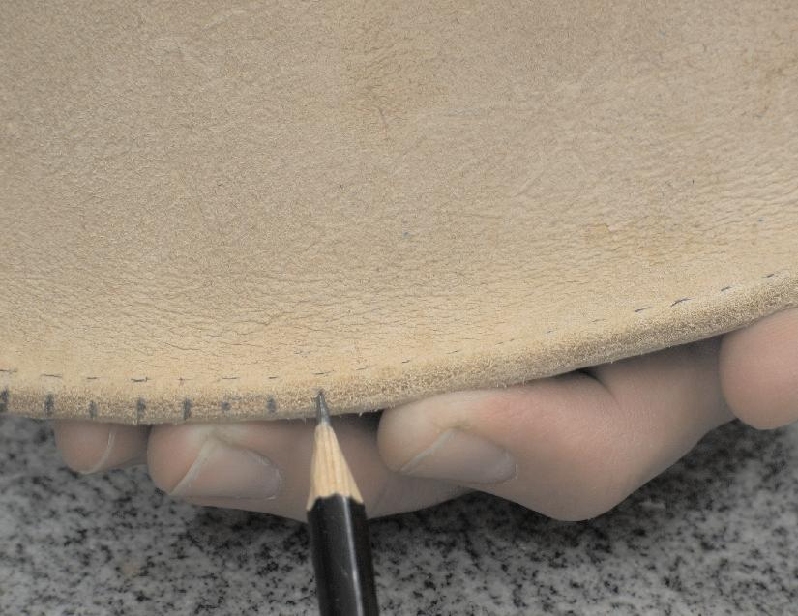
After the sole has dried, mark the location of the stitching holes on the edge of the turned-up sole. This will make it easier to stitch the upper to the sole.
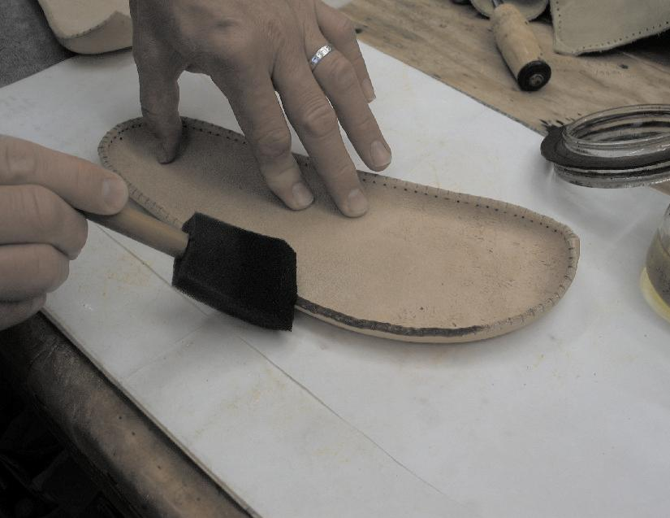
After stitching holes have been marked, apply a heavy even coat of extra virgin olive oil to the edge of the sole. I use a foam brush.

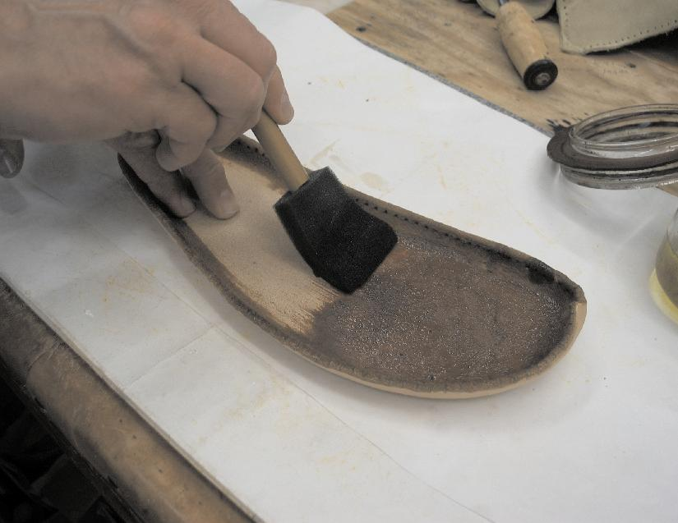
Next, apply a heavy even coat of extra virgin olive oil to both the inside and outside of the sole. This should be done before assembly with the uppers so the soles can be universally treated with oil without discoloring the uppers.
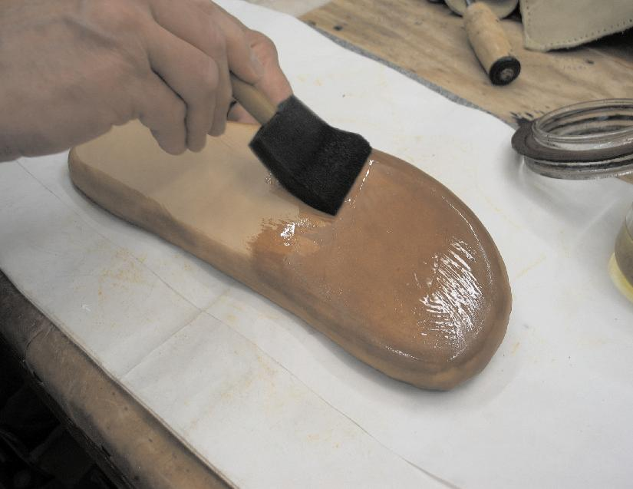
Two coats to the bottoms of the soles will serve the boots well. Periodically, it may be necessary to reapply extra virgin olive oil for the protection of the soles.
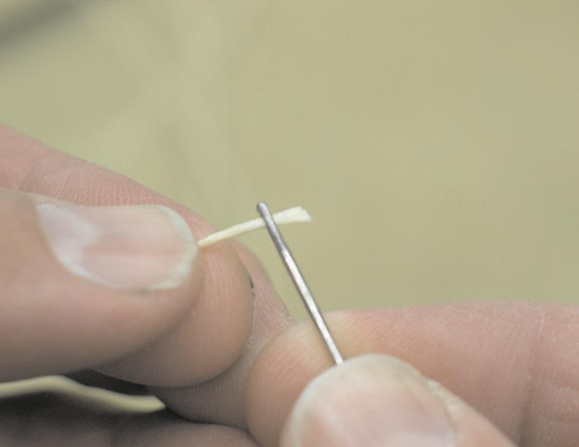
While the oil is soaking into the soles and getting evenly distributed throughout the fibers, it’s time to start stitching the uppers together.

You will need to start with an arm’s span of thread and two hand stitching needles. If you aren’t using pre-waxed thread, you need to wax your thread before you continue.

Stick one end of the thread through the eye of the needle as shown at the left.
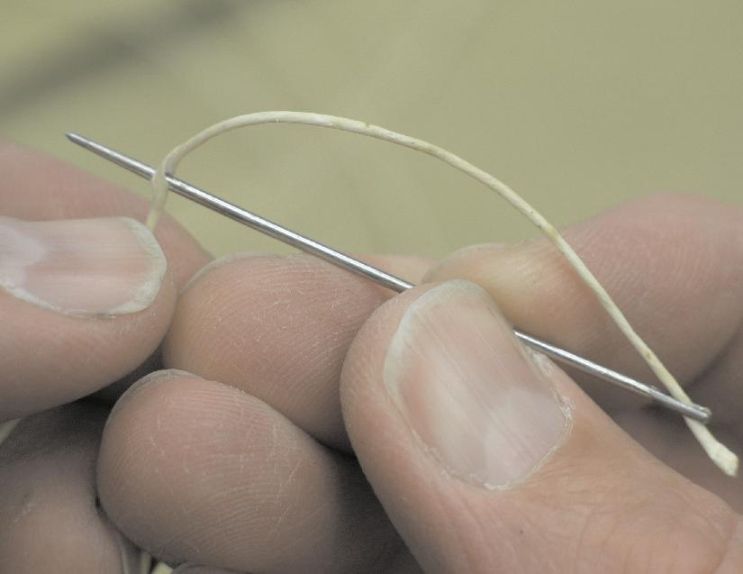
Then, pierce the thread with the point of the needle as shown to the right. Try to pierce the needle as close to the center of the thread as possible.

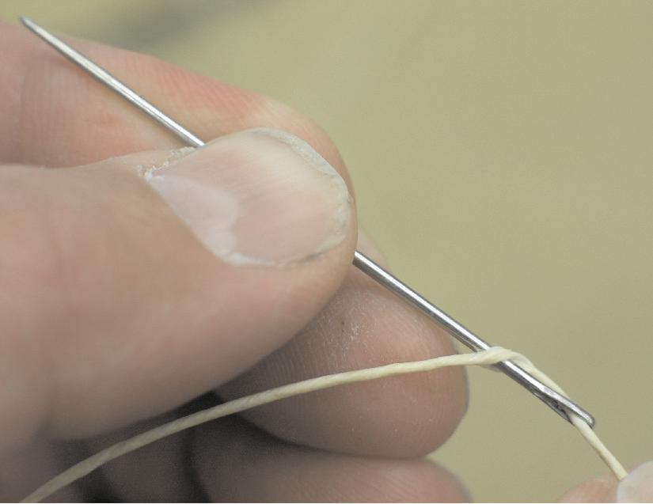
Then, pulling on the end of the thread, slide the piercing down the needle till it is almost to the eye of the needle.

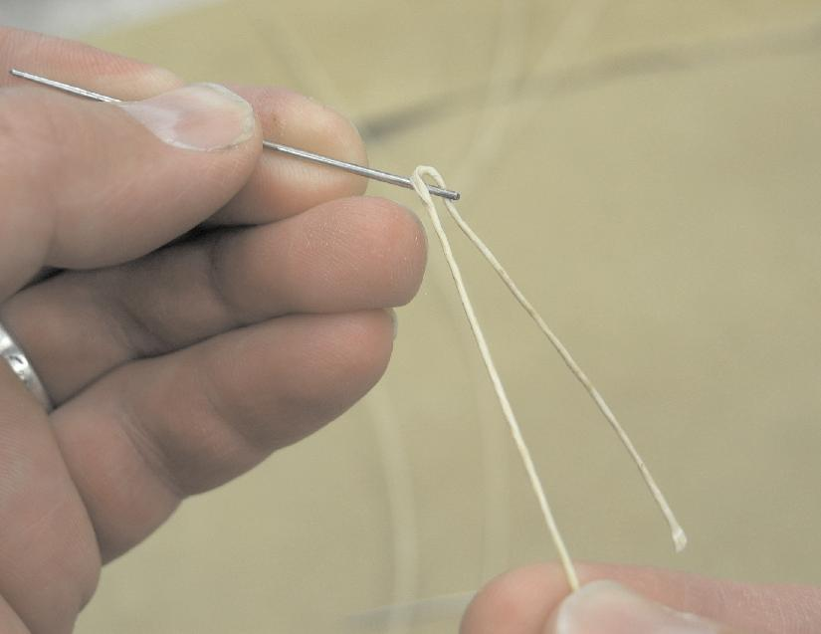
Grasp the thread above the piercing and gently pull it over the eye of the needle as shown at right.
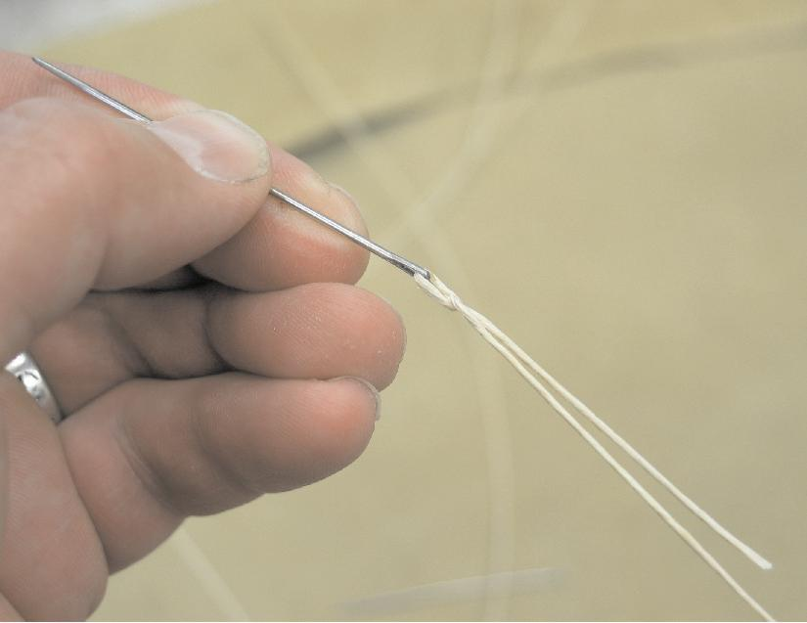
The piercing will slip off the needle and lock itself to the end of the thread. This knot can be waxed to reduce wear and extend the effective life of the knot.

Now, repeat the same process with the other end of the thread so you have a needle at both ends of the thread.
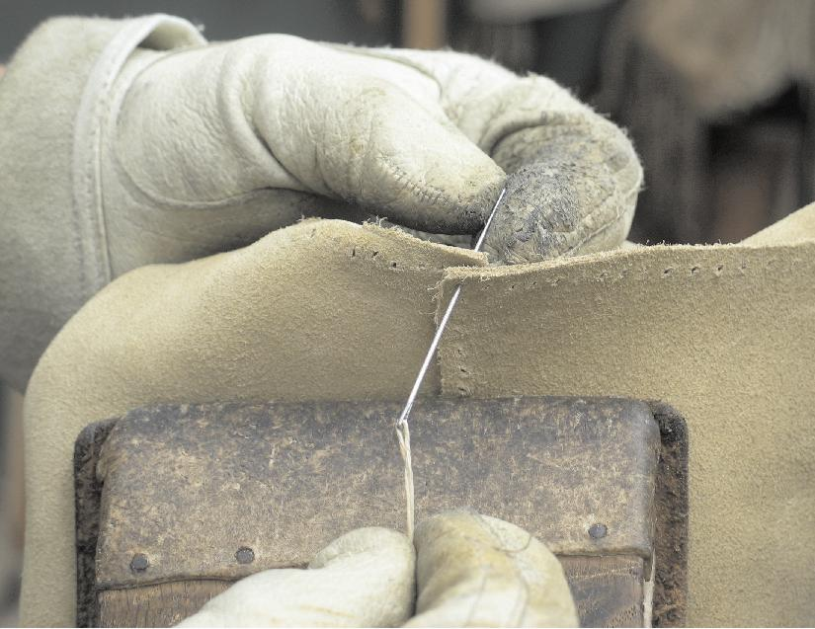
The next step is to sewn the heel seam of the uppers from where the heel will meet the sole, up to the top of the boot.
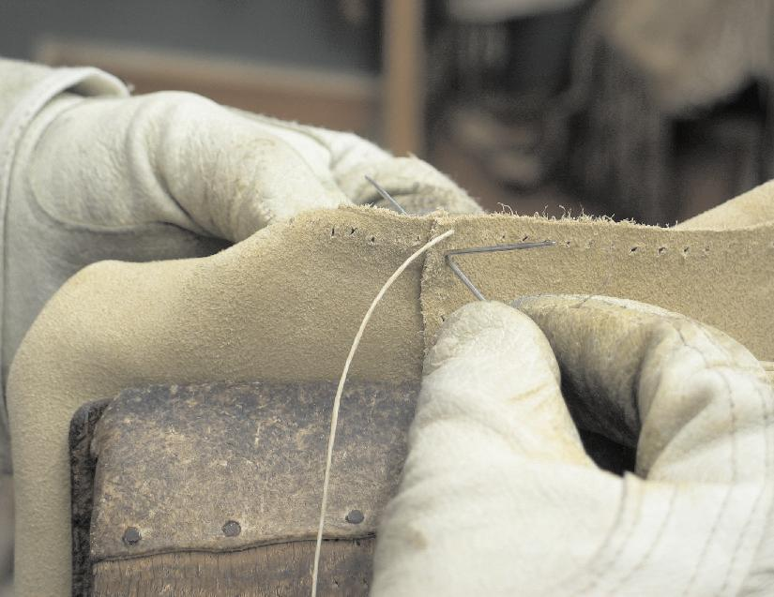
The markings should be on the inside of the uppers as the heel seam is wrapped around to meet the opposite side. It doesn’t really matter how the heel seams overlap each other, as long as you do both boots the same way.

Run the needle through the first set of holes till you have the same amount of thread on both sides. Then run both needles through the second set of holes from opposite directions, as seen in the photo to the left.
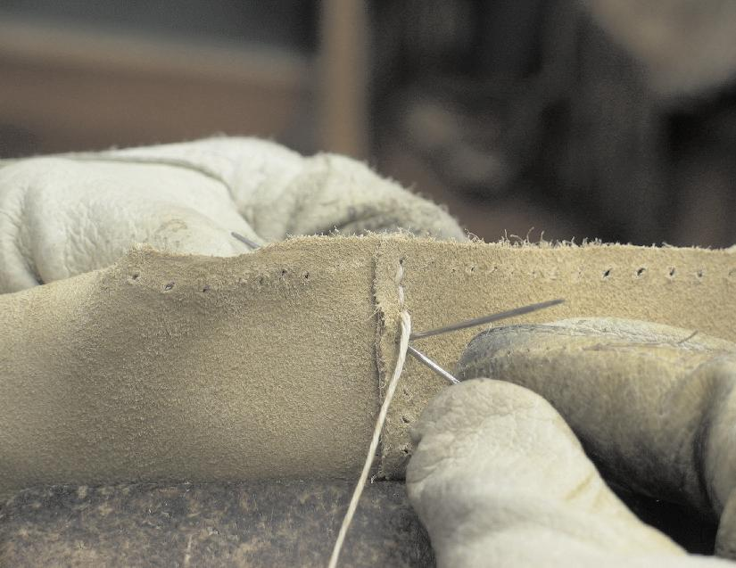
Pull the threads as tight as you can without puckering the leather. Continue the procedure till you’ve sewn your way all the way to the top of the boot.
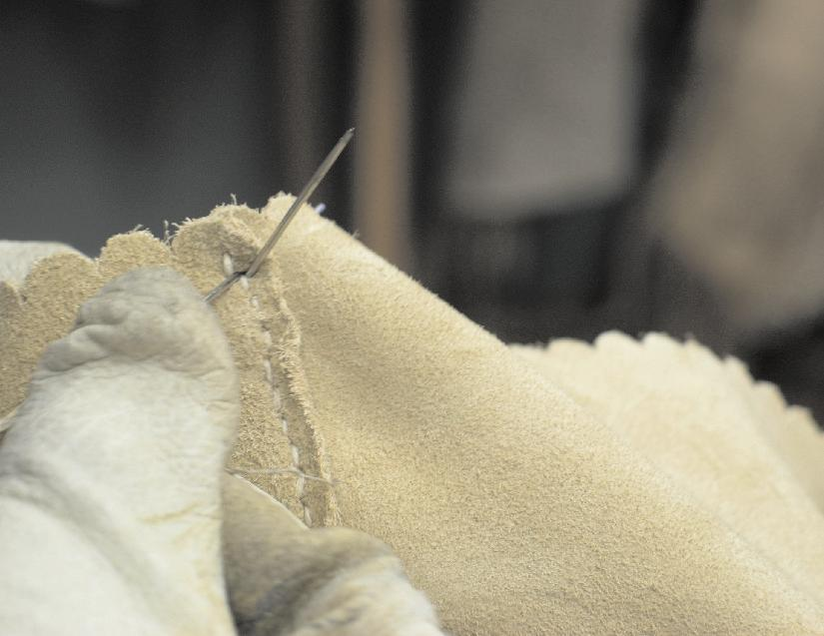
When you reach the top, backstitch back down the boot two and a half stitches, so both ends of the thread are on the outside. Cut them off flush with the leather.
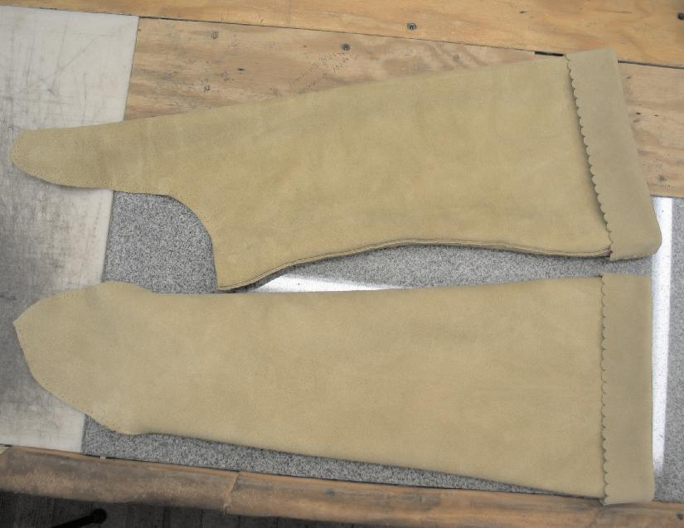
Then the uppers are sewn and the tops folded down, they will look like this. This is the distinctive look of Apache Boots with the seam running up the back. Apache Boots are sometimes sewn with the seam up the inside of the leg, and sometimes, with a seam up both sides of the leg. However, for overall look and ease of construction, I much favor the one seam in the back.
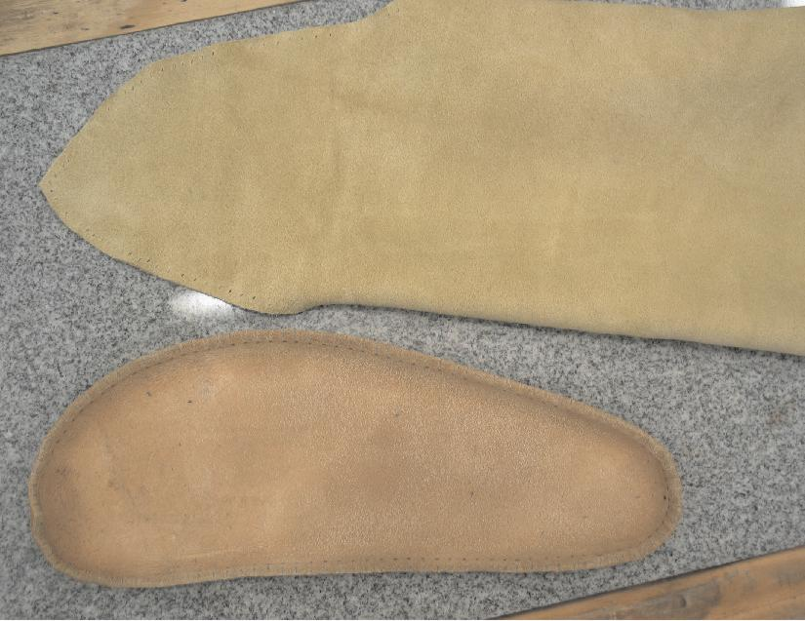
Before the soles are sewn to the uppers, you must first get the right sole with the right upper. In the photo to the right you see the right upper and the right sole laying side by side. Notice how the angle of the upper as it runs over the ends of the toes matches with the angle of the sole as it wraps around the foot.

Again, you will need an arm’s span of thread for stitching the sole to the upper. Prepare the thread as before and attach needles at both ends as previously explained.

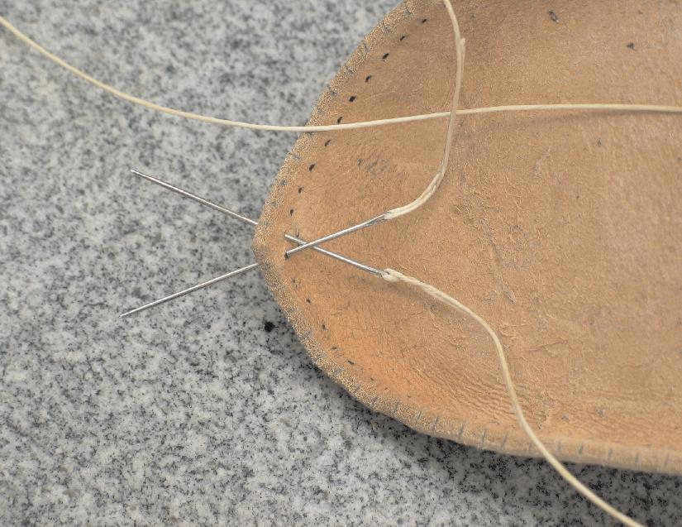
The first two stitching holes in the sole have been identified previously by a mark between them. Locate those two holes and run the needles through the holes from the inside out as shown at the left.
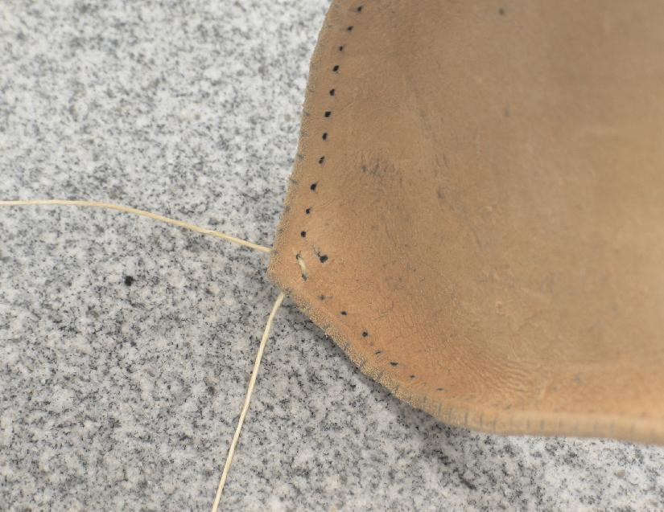
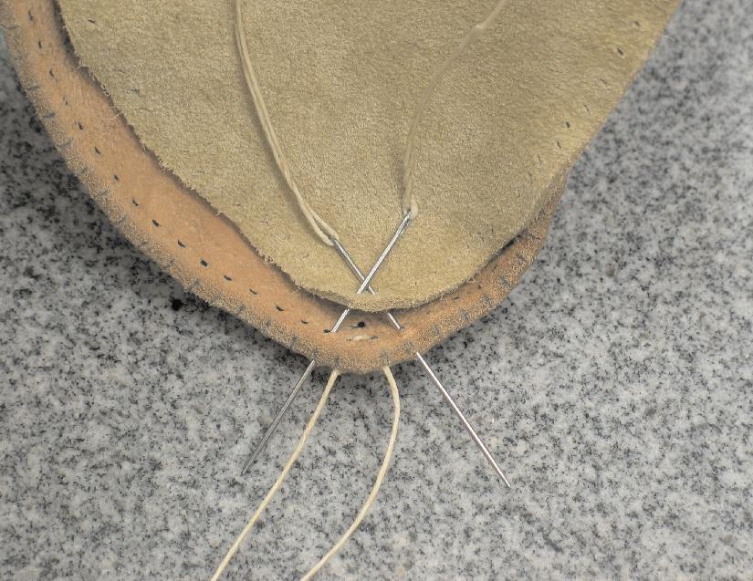
Pull both threads even till the thread is snugged-up inside the toe of the sole as shown to the right.

Align the uppers over the sole as shown to the left. Run needles through the first two stitching holes in the uppers, then through the second holes in the sole as shown.
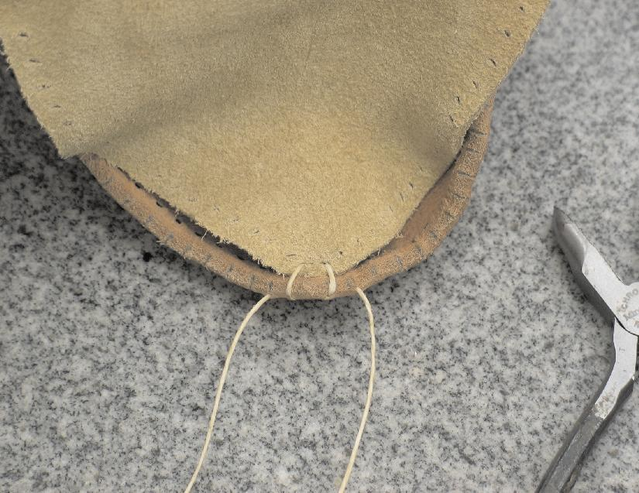
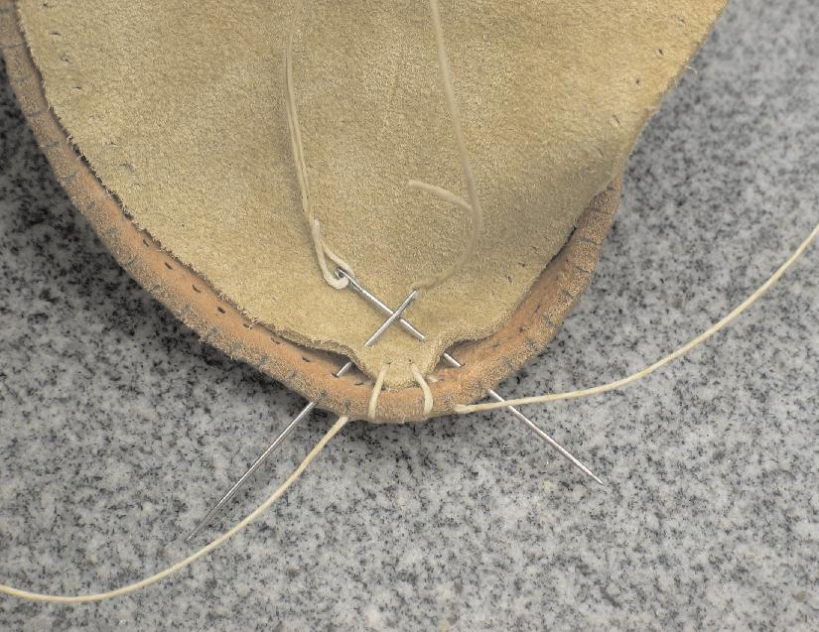
Pull the slack out of both threads as sown to the right.

Run both threads through each of the second stitching holes in the upper and through the third stitching holes on each side of the sole, as shown in the photo to the left.

Pull thread through, removing most of the slack, but don’t pull stitches tight at this point.

Continue stitching down both sides of the boot in this same manner for several inches.

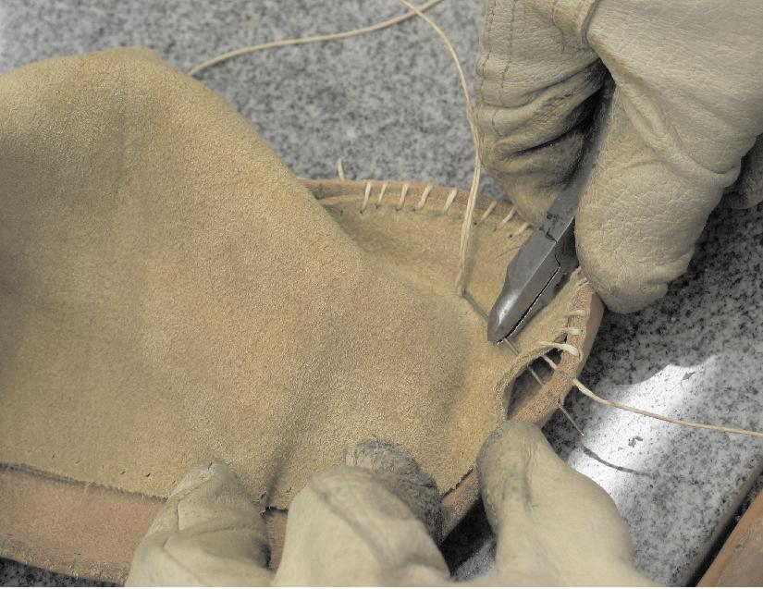
You may find it easier to use a needle nose pliers to handle the needle, as shown in the photo to the left.
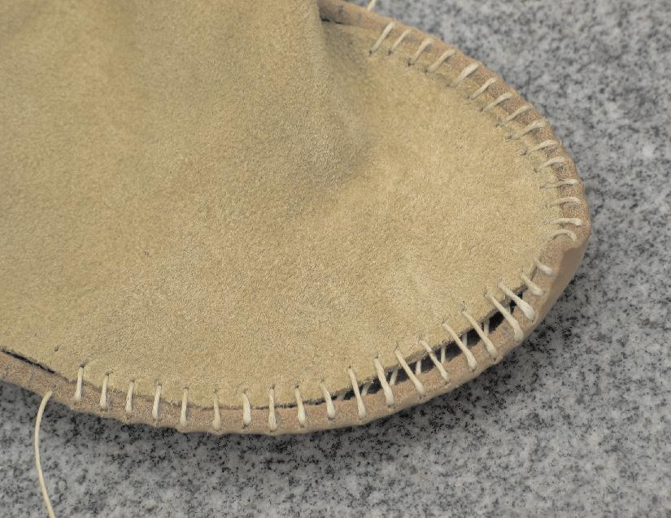
When you have stitched a ways down the boot, it is time to go back and systematically tighten the existing stitches.
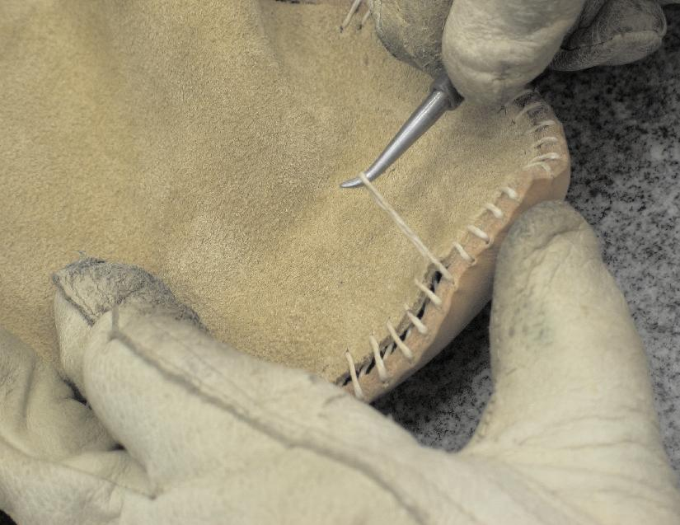
Starting at the point of the toe, begin to pull the slack out of the thread down both sides of the toe. In the photo to the left I am curling the toe more with my free hand as I pull the slack out of the thread. This procedure will have to be done several times before the toe is stitched tight enough to move on with the stitching.
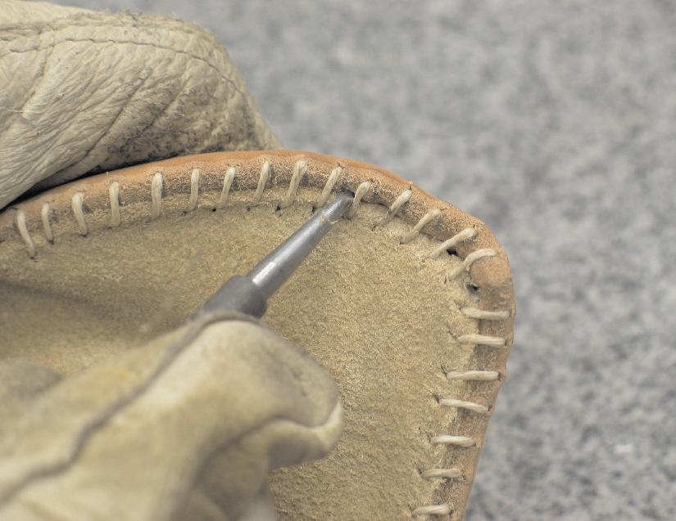
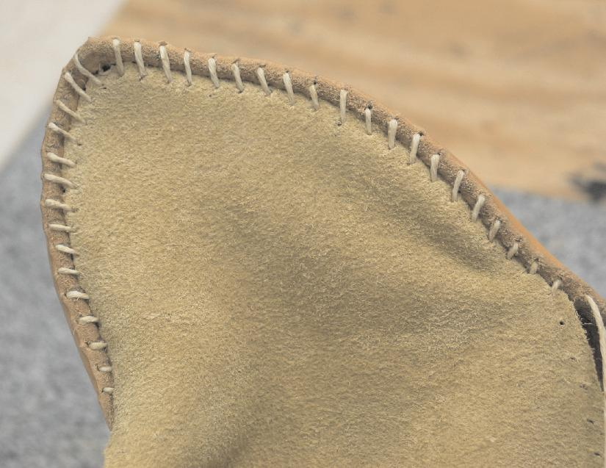

Before tightening the stitches a second time, use a stylus, or some other pointed (but not sharp), tool to tuck the edge of the upper down between the stitches and the sole as shown above.

When tucked in, it should look as it does to the right.

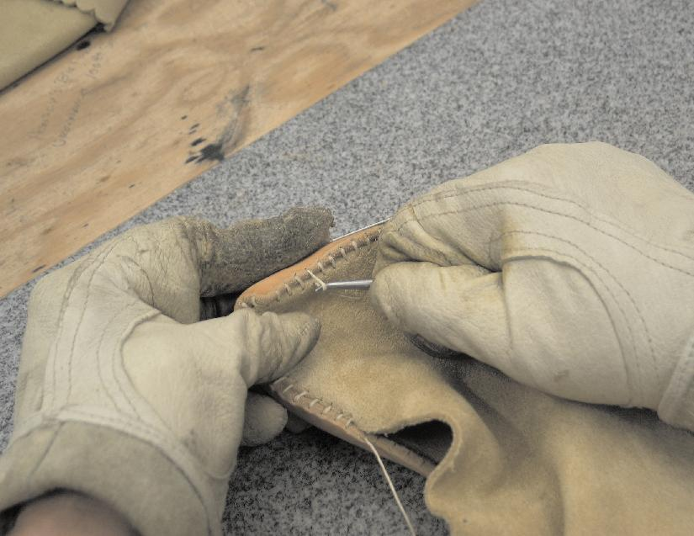
For the final tightening, really curl the sole as the slack is being systematically pulled out of the thread from the toe outward. As can be seen in the photo to the left, a great deal of pressure is put on the thread, but make sure not to break it.
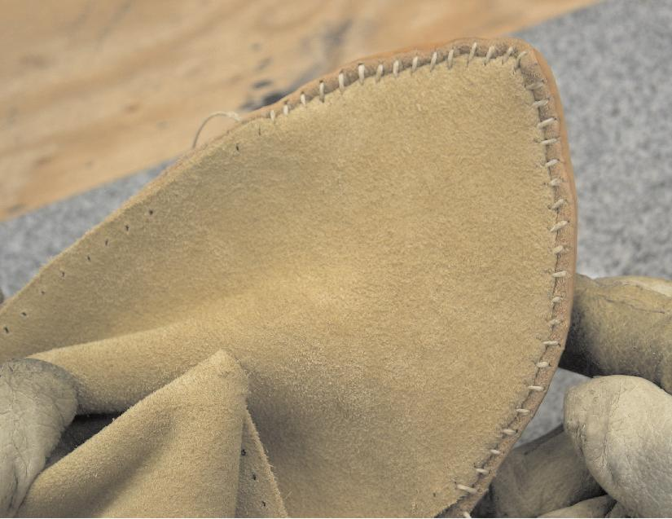
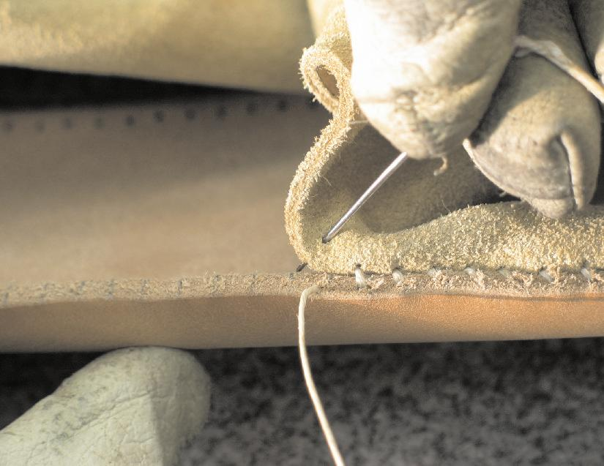
When tightened, it should look even with the upper stretched tight across the toe area as at right.

Stitching can now continue down both sides of the sole. In the photo to the left you can see how the needle goes through the next stitching hole in the upper, and then into the inside stitching hole in the sole. This is where the marks on the edge of the sole showing where the stitching holes are, come in handy.
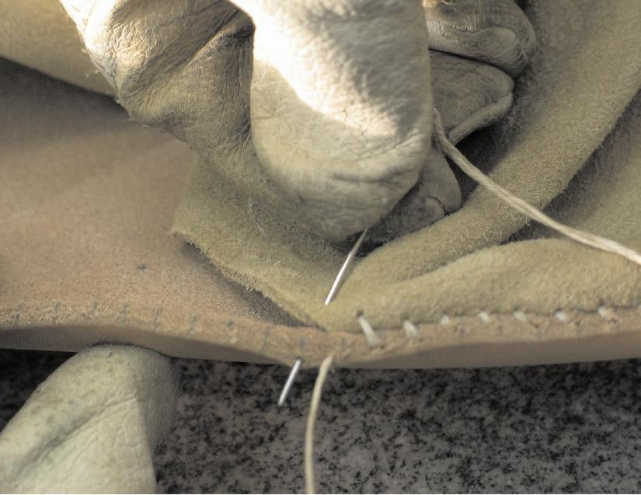
The needle exits the edge of the sole where it is easily grasped and pulled tight, at the right.
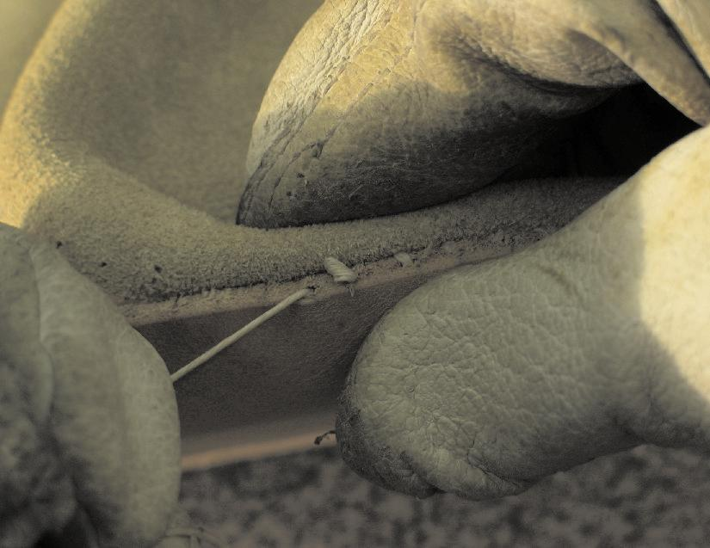
As the thread is pulled tight, it helps to pinch the upper and the sole together to take as much pressure off the thread as possible. This makes for a tighter seam and reduces the chances you will break your thread before you complete sewing to the heel seam.

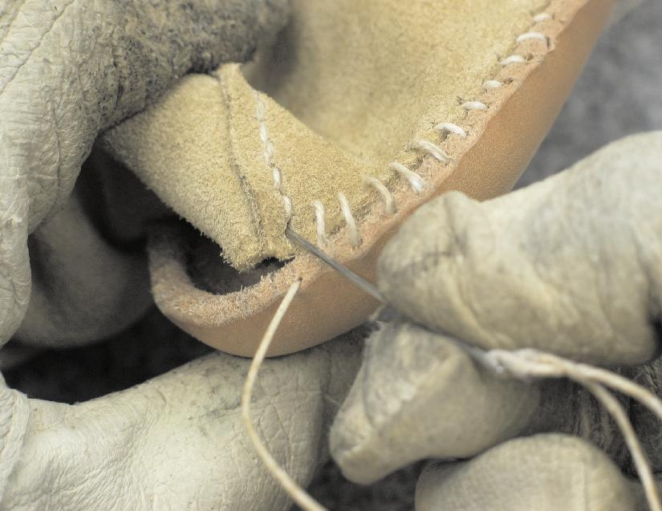
As the stitches round the back of the heel towards meeting the heel seam, begin to leave some slack in your stitches as shown in the photo to the left. The final stitch from this side will go in through the first stitching hole in the heel seam.
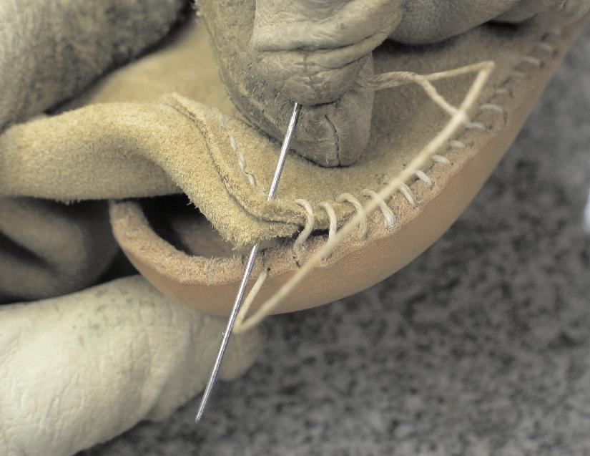
Bring the thread out between the upper and the sole as shown to the right.
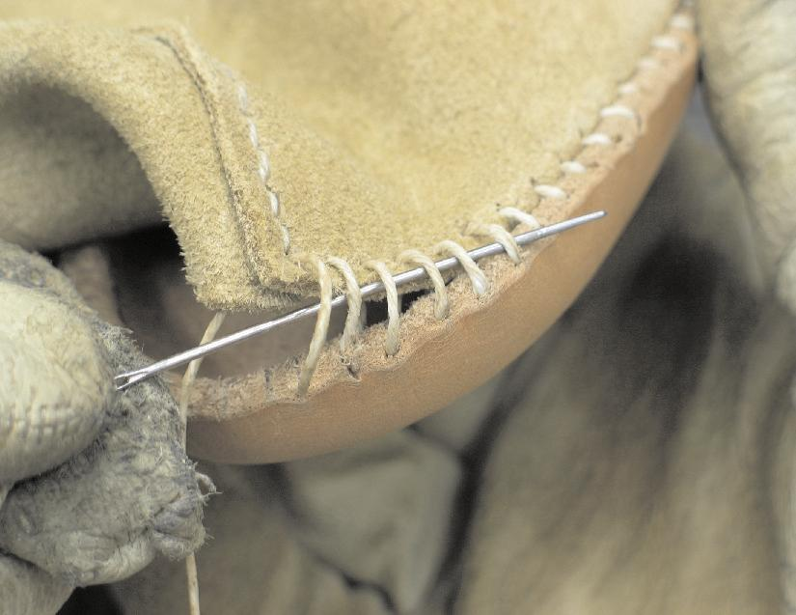
Run the thread back through several of the existing loose stitches as shown in this photo to the left.
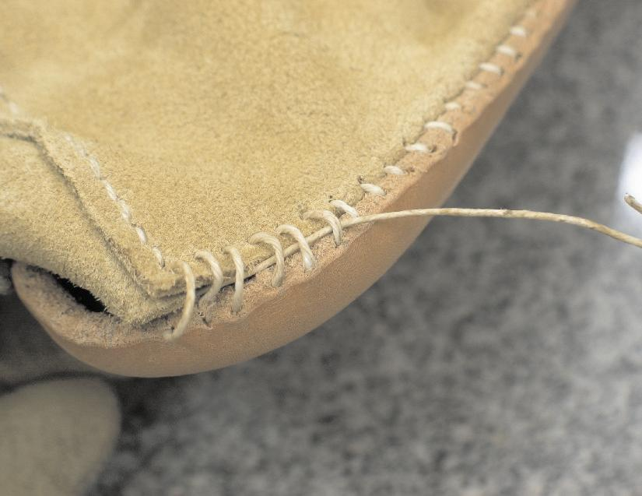
Leave it hanging loose as shown at the right and continue stitching down from the toe on the opposite side.
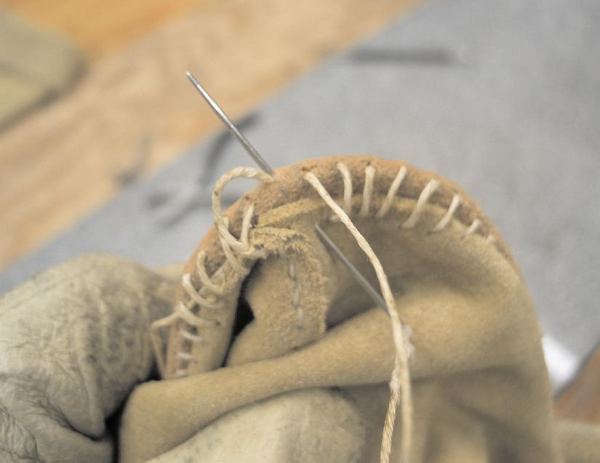
As the opposite side stitching rounds the heel, begin to leave slack as before. As shown in the photo to the left, the final stitch will come out the same sole stitching hole as the thread from the first side.

This thread will now enter the first stitching hole in the heel seam of the uppers, as was the case on the first side.

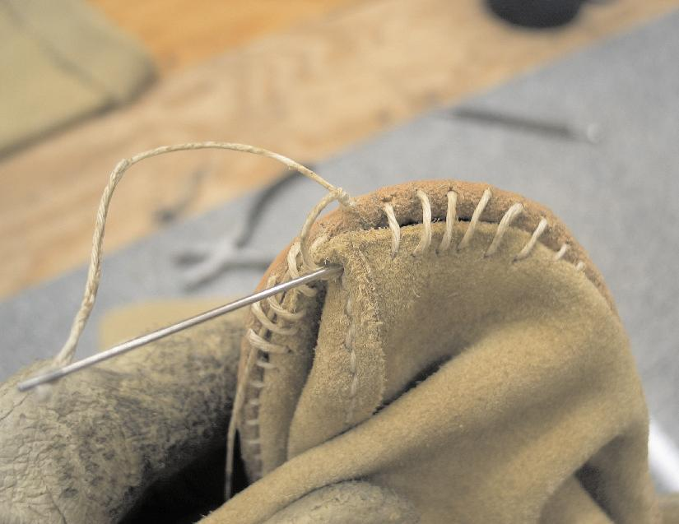
Here to the left, the needle goes into the first stitching hole in the heel seam of the uppers.
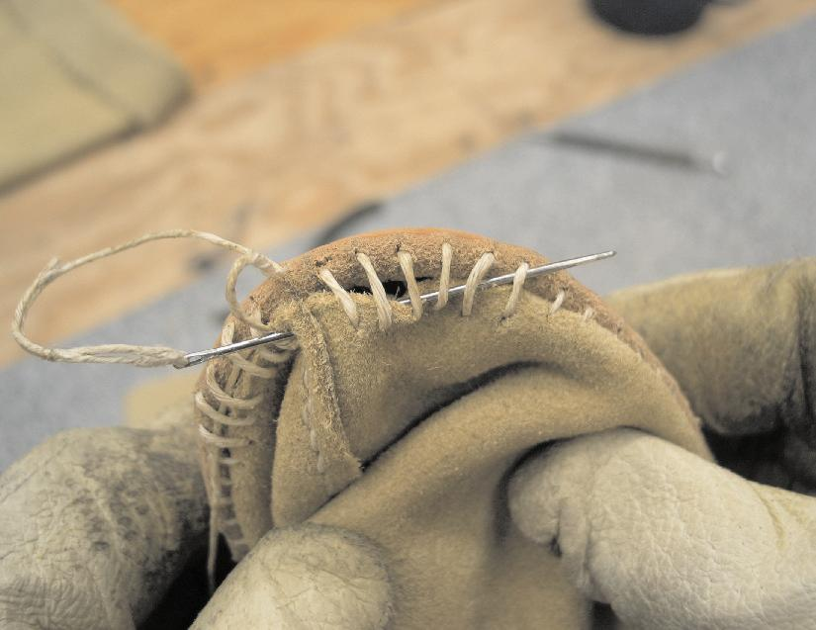
Run the thread back through the slack stitches as before.
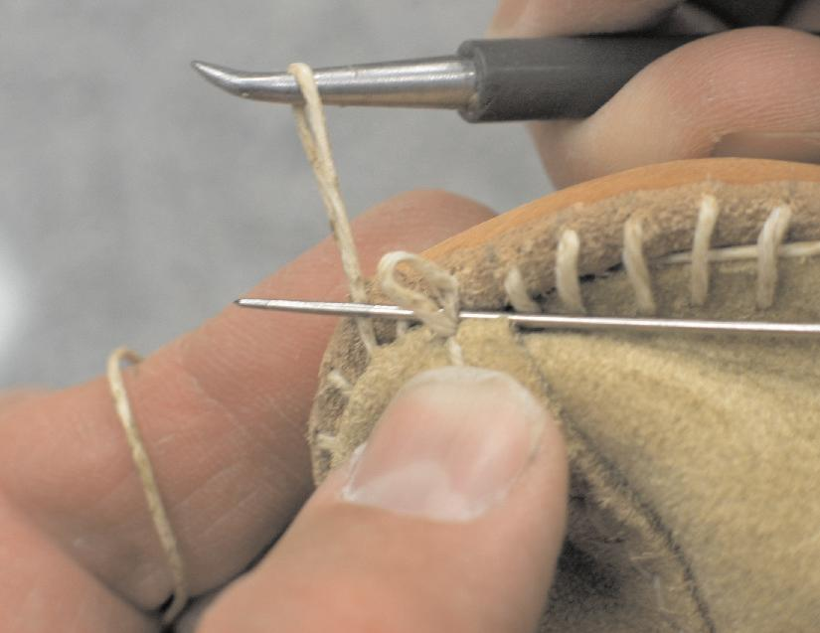
Begin pulling the slack out of the thread again, working towards the final stitch in the heel seam from both sides. In the photo to the left, I have placed a spare needle between the last stitches to make the final stitches easier to get a hold of to pull tight.
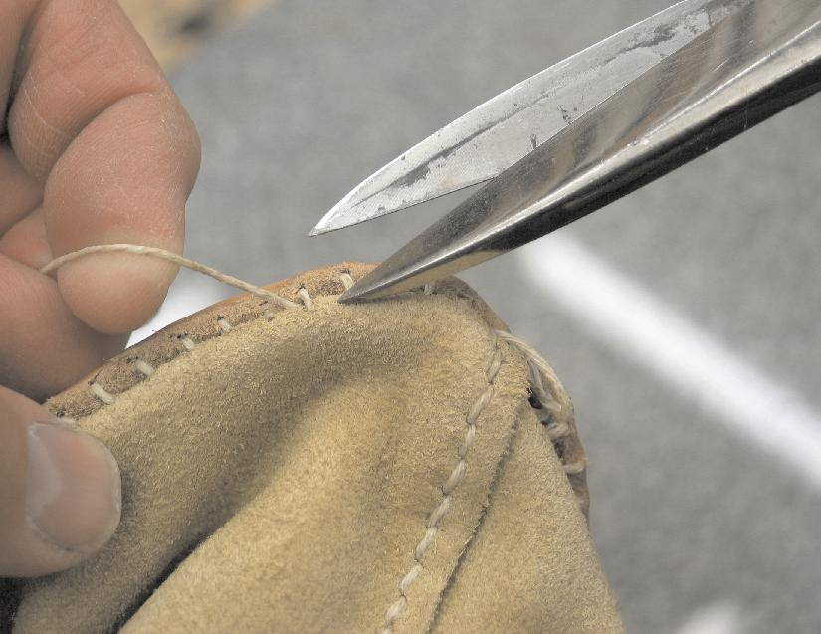
When all the slack has been pulled out of the stitches, the loose end of the thread is pulled through the tightened stitches and cut off flush with the leather as shown at the right.

This is done on both sides. The Apache Boots are now stitched together.

The next step is to cut thin laces to tie around the ankle and the top of the boot above the calf. These can vary in thickness and length, but the thinner the lace, the easier it is to tie.

The lace can be up to ¼” wide. For the ankle, wrap some lace around the ankle to see how much it takes to get around the boot at the ankle. Then, add up to a foot and a half of extra lace to have enough lace to tie off with. The length of the lace can always be cut down if it is found to be too long. Do the same for the calf.

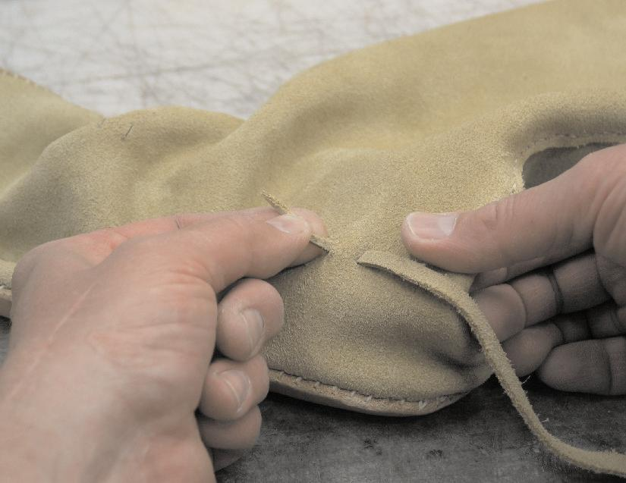
There should be four sets of slots cut for the lace to thread through. Starting on one side at the rear set of slots, run the lace through as shown at the left. Then, do the same thing with the rear set of slots on the other side. Pull the ends of the lace as even as possible before running the lace through the front set of slots.
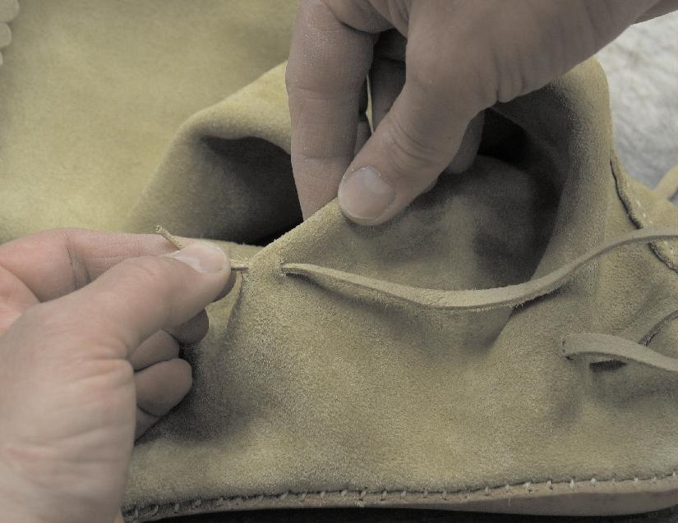
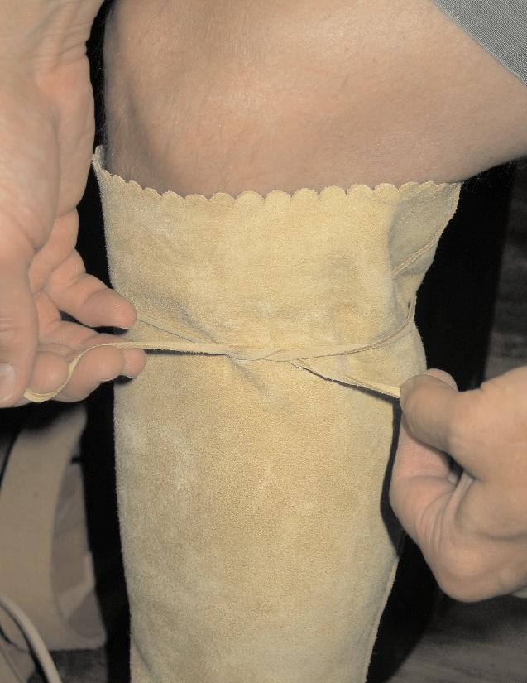
At the right, the lace is being run through the front set of slots.

To slide the boot on, leave the ankle laces loose. Point your toe down as far as possible and slip it into the foot of the boot. The ankle area is designed to be tight to avoid a lot of baggy leather, so It may take some work to get your foot into the boot until they are broke in.
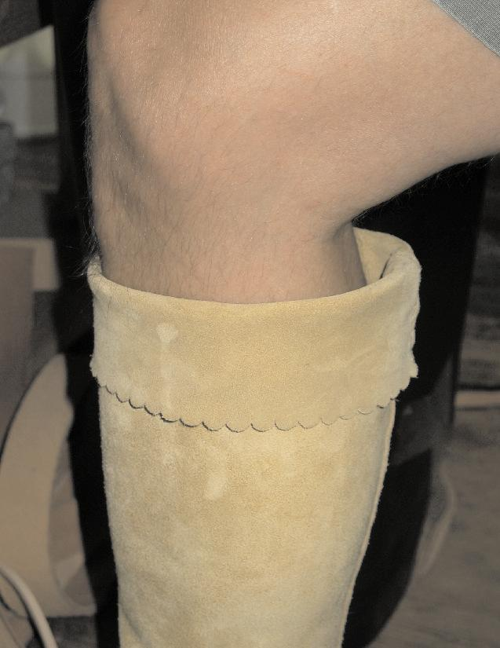
Tie a lace above the calf, but not so tight as to restrict blood flow. Fold the top of the boot down over the tied lace. You are ready to hit the desert and high plains in style now!

Length of boot top can be modified to suit personal taste.

All portions of this instructional booklet are under copyright and cannot be reproduced, copied, or printed for sale. This tutorial is provided free of charge for the benefit and success of my customers.

Thanks You!

Will Ghormley

